**Tide gauge observation land uplift evaluation using Satellite Altimetry**

# Introduction

The aim of study is to check if the land uplift (LU) has been applied to the TG observations data or not also if applying other corrections including Dynamic Atmospheric Correction (DAC) and Ocean Tide (OCT) will improve the agreement between the SA and TG or not. To do so 3 passes of Sentinel-3A during the year 2016-2019 (33 cycles) compared with TG data in two cases I) without applying LU (w/o LU) to TG observations II) adding LU to TG observations.

These passes are selected as they cross the whole Baltic Sea from south to north part of the sea. The TG stations along these passes are selected and used in this study. Figure 1 shows the location of the passes and table 1 showing the selected TG of each pass.

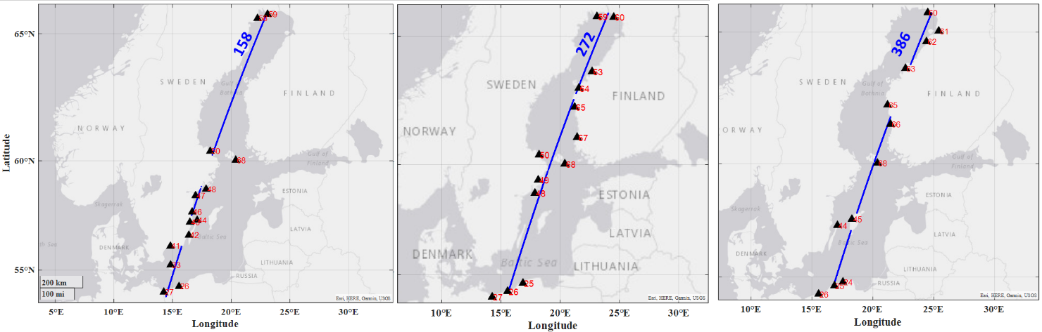

Fig.1: Sentinel-3A passes used for this study in Baltic Sea together with TG stations location

Table.1: Selected TG station along each SA pass.

|  |  |  |  |  |  |  |  |  |  |  |  |  |  |  |
| --- | --- | --- | --- | --- | --- | --- | --- | --- | --- | --- | --- | --- | --- | --- |
| Pass# | TG ID | | | | | | | | | | | | | |
| 158 | 59 | 50 | 47 | 46 | 43 | 26 | 27 | 33 | 41 | 42 | 44 | 48 | 68 | 58 |
| 272 | 25 | 48 | 65 | 64 | 60 | 67 | 26 | 27 | 49 | 50 | 68 | 63 | 59 |  |
| 386 | 24 | 45 | 68 | 63 | 66 | 60 | 61 | 62 | 65 | 25 | 26 | 44 |  |  |

Figure 2 shows the applied LU variation in the area. The TG land uplifted observation used in this study are pre-processed by Vahidreza.

Fig.2: Land uplift surface used in this study by NKG2016LU_lev model

# Methodology

SA data are considered in 3 cases a) adding DAC b) DAC correction de-corrected c) adding DAC and OCT correction using below Equations after applying the ellipsoidal correction

${SSH}_{no dac}={SSH}_{ALES+}+DAC$ (1)

${SSH}_{+DAC}={SSH}_{ALES+}$ (2)

${SSH}_{-OCT}={SSH}_{ALES+}-OCT$ (3)

The DT of SA of each above-mentioned case is obtained by Eq.4:

${DT}_{SA}=SSH-N$ (4)

where N is the geoidal height extracted by NKG2015 geoid model and SSH values are considered in 3 cases measured by Eq.1-3. The difference between the TG and SA is obtainable by each case using Equation 5

$ΔDT={DT}_{SA}-{DT}_{TG}$ (5)

where DTTG are considered in two cases a) with LU b) w/o LU. TG data along the pass are interpolated linearly at SA locations to compare these datasets together

And the RMSE and correlation coefficient (corr) between DTSA and DTTG are obtainable using below equations:

$RMSE=\sqrt{\frac{1}{m}\sum_{i=1}^{m}{{ΔDT}_{i}}}$ (6)

$Corr=\frac{\sum_{i=1}^{m}{\left({DT}_{SA}-\overline{{DT}_{SA}}\right)-({DT}_{TG}-\overline{{DT}_{TG}})}}{\sqrt{\sum_{i=1}^{m}{{\left({DT}_{SA}-\overline{{DT}_{SA}}\right)}^{2}-{({DT}_{TG}-\overline{{DT}_{TG}})}^{2}}}}$ (7)

where m is the number of SA data happening at each cycle of each pass, $\overline{{DT}_{SA}}$ is the mean of DTSA and $\overline{{DT}_{TG}}$ is the mean of DTTG in the same pass.

To check if the LU are already applied to the TG observation or not a 1st degree polynomial function fitted to the ΔDT and the tilt between the fitted line and reference line (y=x) are measured by below equation:

$y=ax+ε$ (8)

$θ={Tag}^{-1}(a)$ (9)

Eq. 8 is the standard format of 1st degree polynomial function and the θ is the deviation angle (tilt) between the reference line (y=x, i.e., DTTG=DTSA) and fitted line. This tilt could show the deviation between the residual DT (ΔDT) along the SA track. In ideal case the tilt should be 0 (a=1). Check Figure 3.

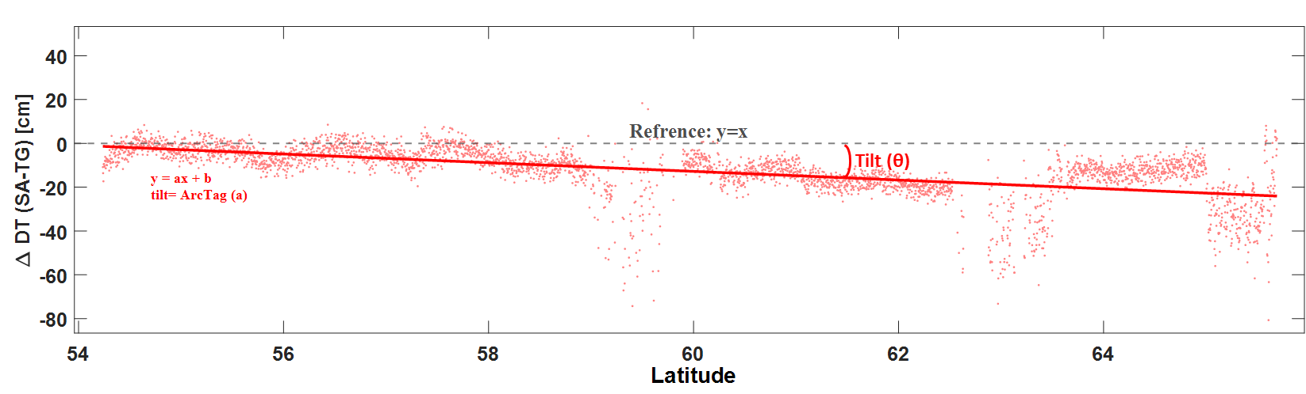

Fig.3: applied methodology to fit 1st degree polynomial (y=ax+b) to the ΔDT and measure the deviation tilt respect to reference line (y=x)

# Results

Figures 4 and 5 show the along track DTSA together with the TG observations available nearby the pass. The TG values are showing by adding the LU (red circles) and without adding the LU (green circles)

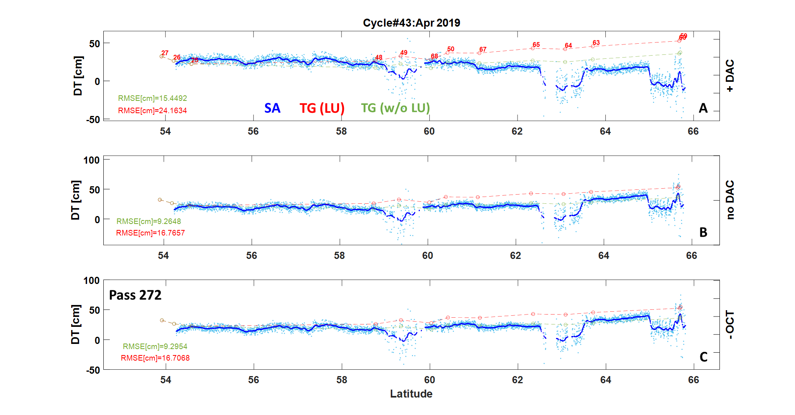

Fig.4: Along track DTSA using pass 272 Cycle 43 in 3 cases: A) DAC considered B) DAC de-corrected C) DAC and OCT considered

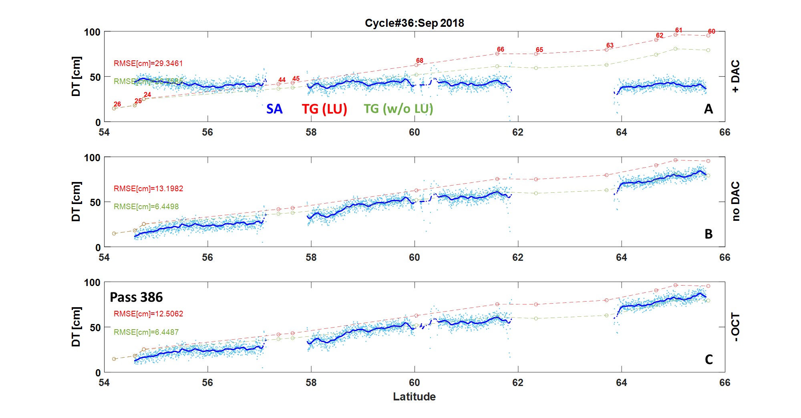

Fig.5: Along track DTSA using pass 386 Cycle 36 in 3 cases: A) DAC considered B) DAC de-corrected C) DAC and OCT considered

Figure 6 shows the correlations between DTSA and DTTG in 2 cases: I) without LU (green) II) adding LU (red) in 3 cases: A) DAC considered B) DAC de-corrected C) DAC and OCT considered

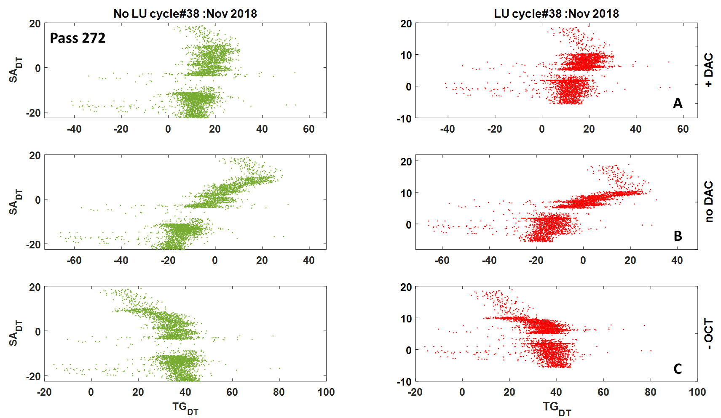

Fig.6: correlation between DTSA and DTTG in pass 272 cycle 38

Figure 7 shows the correlation coefficient (corr) of DTSA and DTTG in 3 cases with LU (red) and w/o LU (red) during 2016-2019

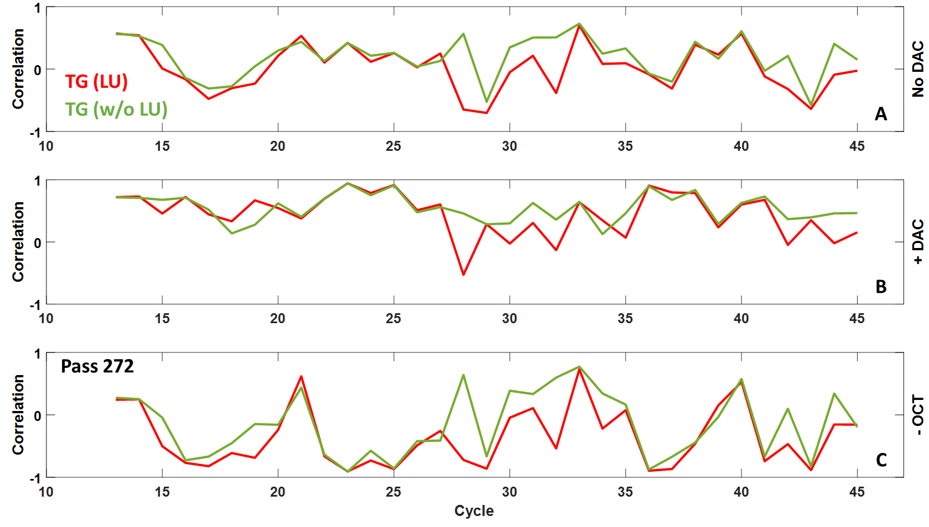

Fig.7: correlation coefficient of DTSA and DTTG in pass 272 all cycles

Figure 8 shows the residuals DT (DTSA-DTTG) by two TG value w and w/o LU values along the track and fitted line of each case

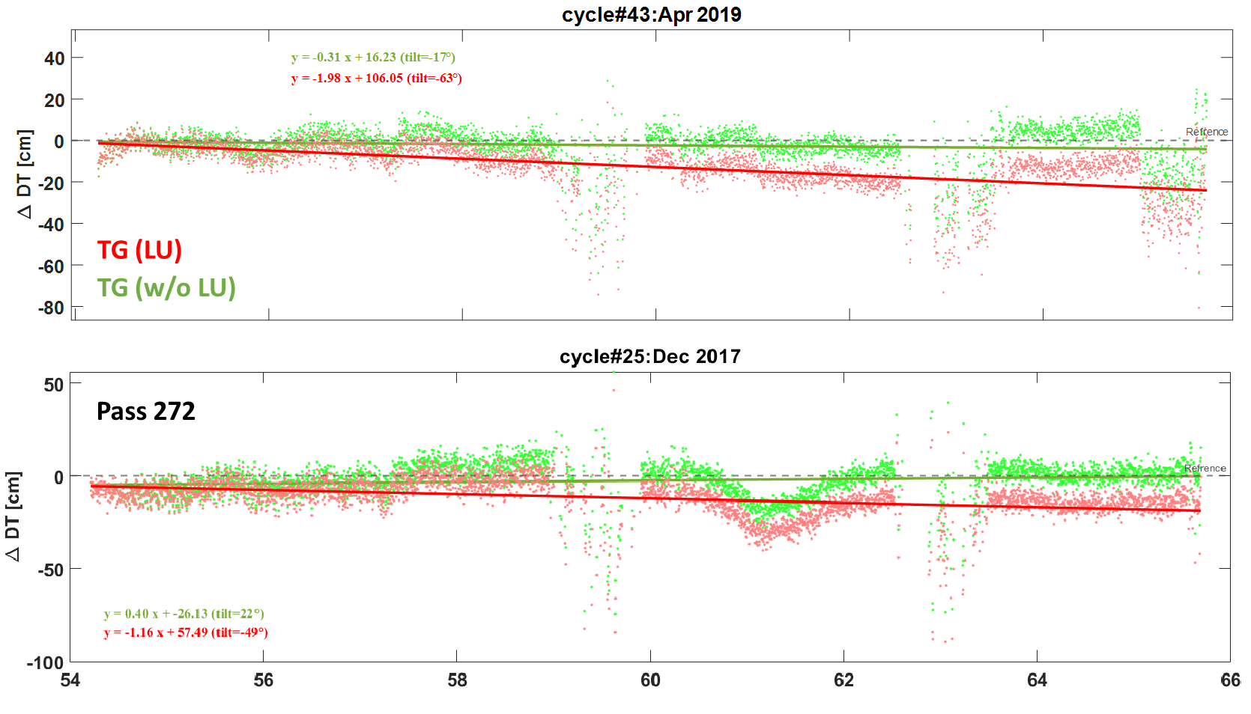

Fig.8: ΔDT and fitted polynomial line of ΔDT along the track between residuals of DT (DTSA-DTTG) in two cases TG with LU (red) and TG w/o LU (green) in pass 272 and 2 cycles.

# Conclusion

1. Applying DAC and OCT corrections will not improve the SA quality respect to TG observations

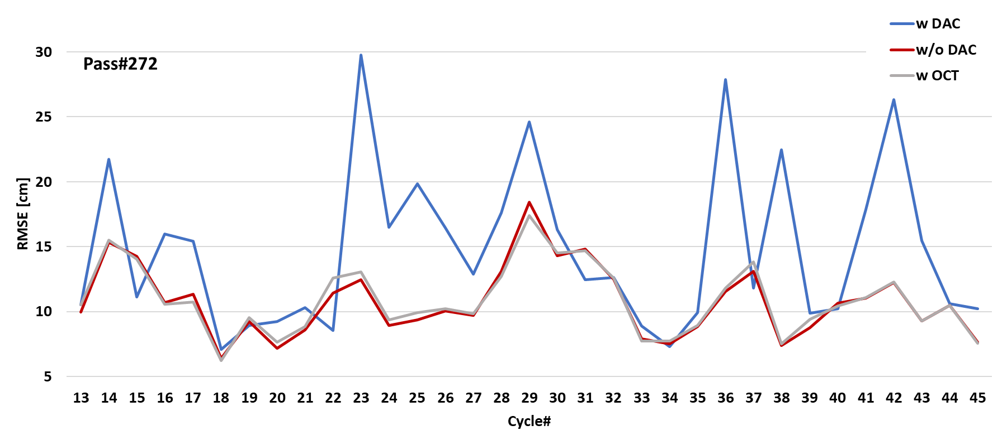

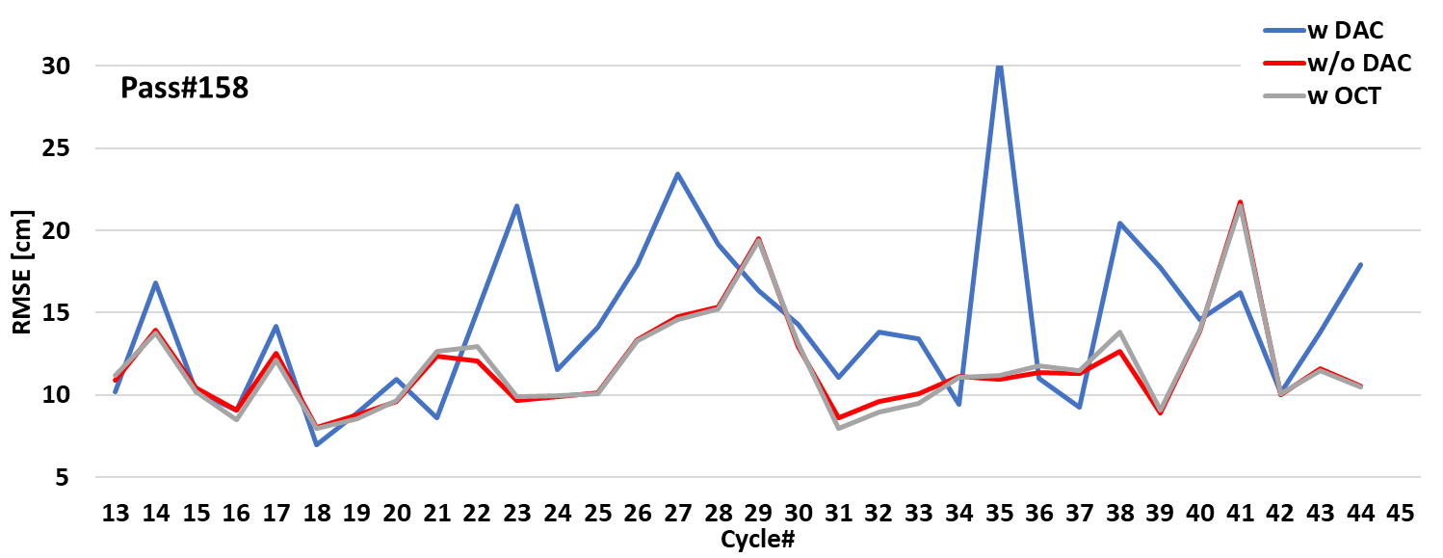

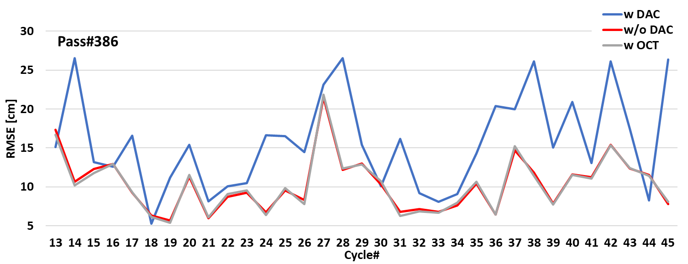

Fig.9: RMSE between SA and TG w/o LU of each cycle during 2016-2019 using 3 passes

1. By comparing the SA data and TG observation in two cases w LU (red) and w/o LU (green) the results show higher deviation along the SA track in LU case in all 3 passes. The green line is closer to the zero line and the mean of tilt angle w/o LU is lower in all 3 passes.

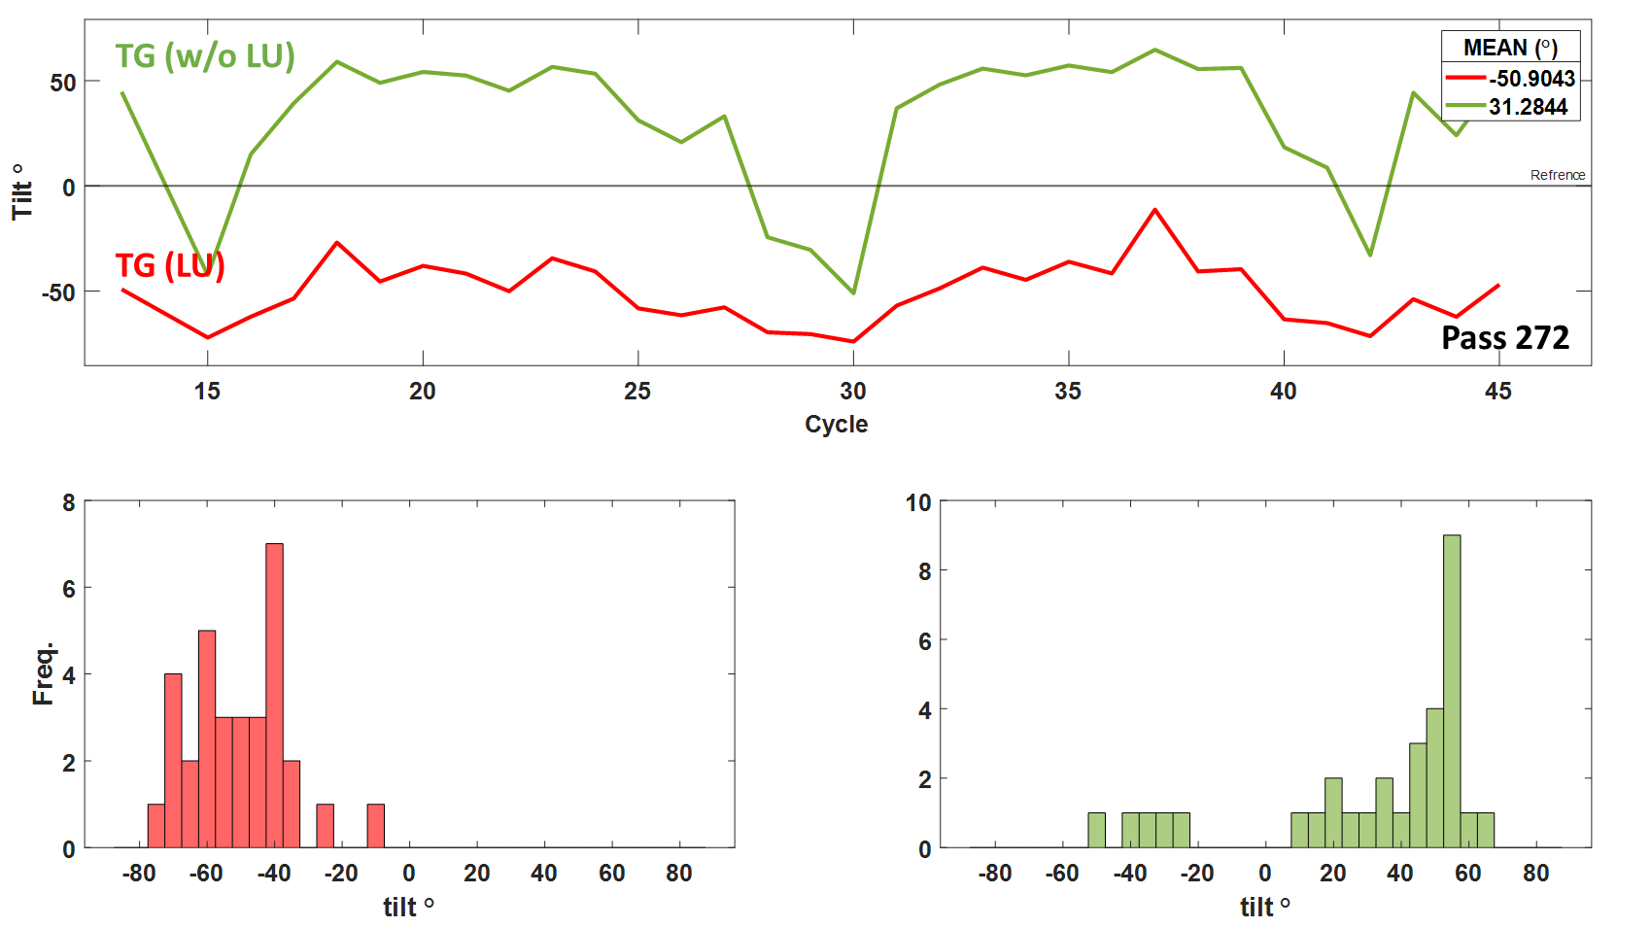

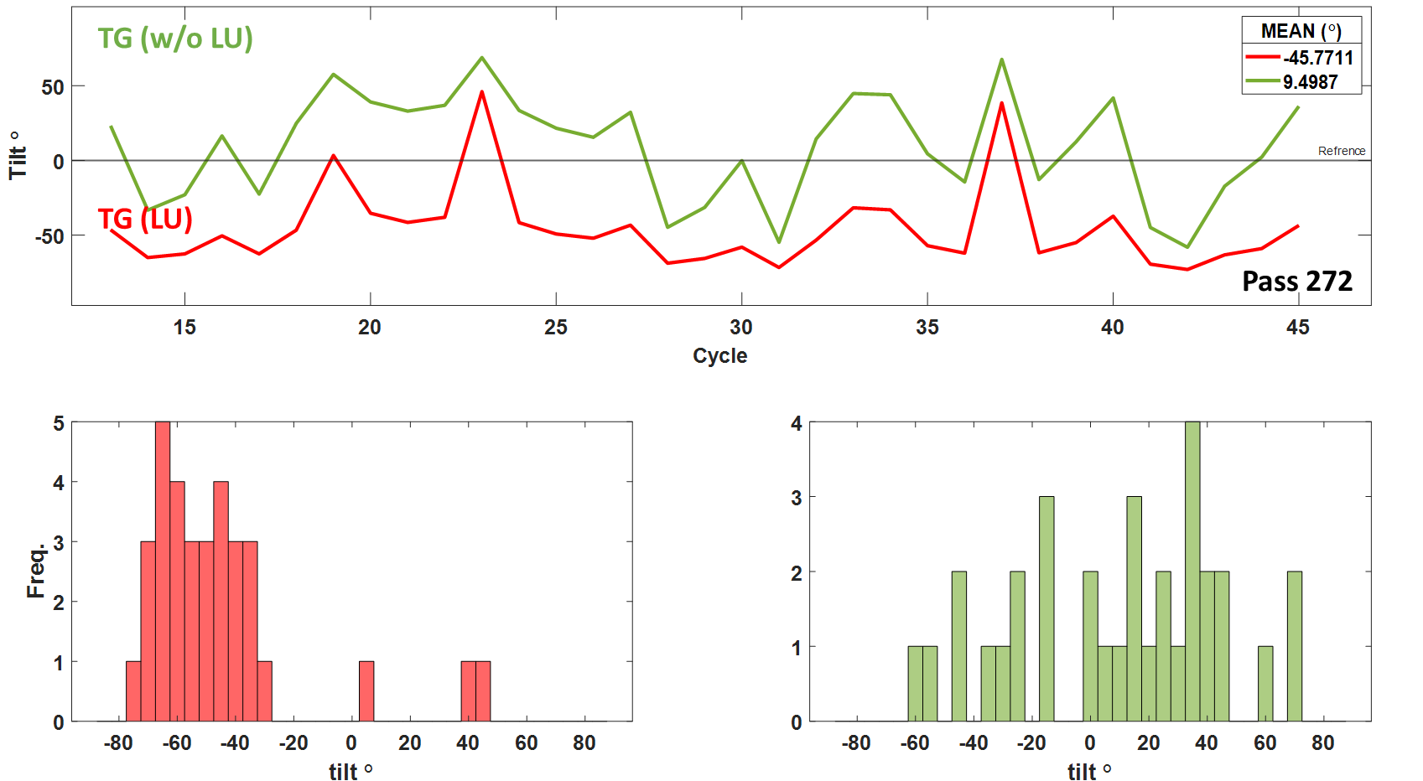

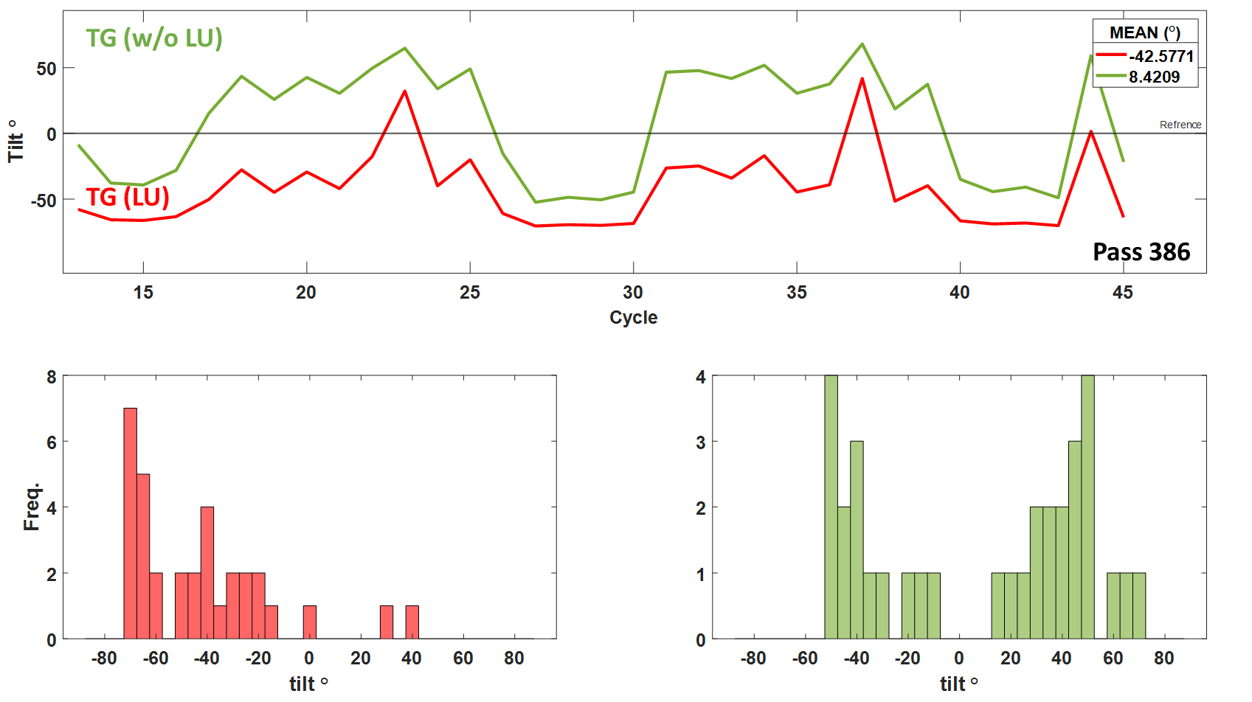

Fig. 10: the tilt between the fitted polynomial line of ΔDT and reference line of each pass during 2016-2017 and the histogram of these tilt. Green is w/o LU and red is w LU